A

Project Report

On

Result Analyzer

(Submitted in partial fulfillment of the requirement for the Award of Degree )
In
Bachelor of Engineering
(Electronics & Computer Engg.)



UNIVERSITY COLLEGE OF ENGINEERING

AFFILIATED TO PUNJABI UNIVERSITY,
PATIALA.
APPROVED BY AICTE

Project By:
Christina Singh
12105053

CERTIFICATE

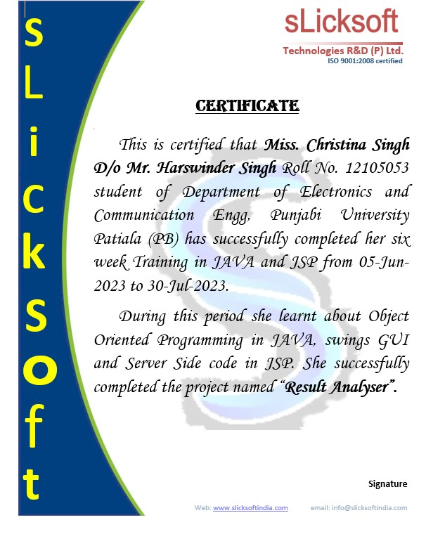

Dr. Ranjit Kaur
HEAD OF THE DEPARTMENT
(Electronics & Communication Engineering)
( University College of Engg.)

DEPARTMENT OF ELECTRONICS AND COMMUNICATION ENGG. , PUNJABI UNIVERSITY ,PATIALA.

CANDIDATE'S DECLARATION
I Christina Singh hereby declare that I have undertaken Summer training at SLICKSOFT TECHNOLIGIES, PATIALA during a period from 05-06-2023 to 30-07-2023 in partial fulfillment of requirements for the award of degree of B.Tech (Department of Electronics & Communication Engineering) at Punjabi University, Patiala. The work which is being presented in the training report submitted to Department of Electronics & Communication Engineering at Punjabi University, Patiala is an authentic record of training work.

Signature of the Student

The summer training Viva–Voce Examination of has been Held on______________________ and accepted.

Signature of Examiner

ACKNOWLEDGEMENT

Embarking on this journey of learning and exploration would not have been possible without the unwavering support and guidance of many. It becomes imperative for me to express my heartfelt gratitude to those who stood by me, illuminating my path with their insights and expertise, and nurturing my aspirations with their encouragement and faith.

I would like to express my gratitude to Dr. Ranjit Kaur , Head of Department (HOD) of Electronics and Communication department at Punjabi University, Patiala for her unwavering support and invaluable guidance throughout this endeavor. She always stood by our side guiding us to get more and more venture.

I would also express my gratitude to Dr. Gurpreet Khanna whose guidance and support made it possible to undertake and complete this summer training project on Java. His patience , constructive feedback provided helped me and shaped my journey in immeasurable ways.

I owe my deepest gratitude to my family who stood by me through thick and thin, providing both a foundation of strength and a haven comfort. To my friends who provided endless moments of joy and insightful discussions.

With gratitude, I recognize God's hand in this journey, and with hope, I look forward to the paths He will lead me on in the future.
Christina Singh

ABSTRACT

This is intended to be a customized solution for the firms that don’t want to go for packaged products and for the firms limited by the cost factor.

On an average, the small size firms handle the internal activities using standard tools available in the market. Also a lot of internal activities are manually maintained which further involve a lot of paperwork. A need for a central system comes up when many times the problems such as communication gap between two functions or non availability of the required information in the hour of need surface very frequently. The frequent repetition of such problems hampers the smooth functioning of the activities.

Additionally, things get more complicated when the firm grows its operations or processes or increases in size. Hence the availability of customizable tool would help the firms in handling the activities and in the smooth running of the business functions.

Result Analyzer _____________________________________________________________________

Contents
_____________________________________________________________________
Certificate
Acknowledgement
Declaration
Abstract

Chapter Description Page No.

1. INTRODUCTION 1.1 Problem Definition
1.2 Objective
1.3 Features
1.4 Module Description

2. SYSTEM ANALYSIS 2.1 Identification of need
2.2 Preliminary Investigation
2.3 Feasibility Study
2.3.1 Technical Feasibility
2.3.2 Economical Feasibility
2.3.3 Operational Feasibility

3. SOFTWARE REQUIREMENT SPECIFICATION 3.1 System Requirements
3.2 Project Planning
3.3 J2EE
3.4 Bea Web Logic
3.5 Microsoft Data Access

4. SYSTEM DESIGN & DEVELOPMENT 4.1 System Design
4.2 DATA FLOW DIAGRAMS

5. SYSTEM TESTING & IMPLEMENTATION
5.1. System testing
5.1.1. Unit testing
5.1.2. Integration testing
5.1.3. Validation testing
5.2 System implementation
5.3 Post implementation review

6. SNAPSHOTS

7. CONCLUSION & SCOPE
7.1 Future Scope
7.2 Limitations
7.3 Conclusion
8. REFERENCES

CHAPTER1: INTRODUCTION

INTRODUCTION

Result analyzer is basically an interaction between Admin And Student easily through web. This project describes how university result analyzer act or what function he provides to students . This project contain three categories namely ADMIN, STUDENTs through which students can easily interact with admin. Under admin these works are done :

  - Student List
  - Course List .
  - View Feedback.
  - Result

.
Second is Student under this
  - Change Password
  - Course
  - Result
  - Feed Back

BUSINESSIMPACT
  - This project can be very easily used in the process of various purposes in result analyzer, and also very easy way to connect with students and admin. And finally very easy to interoperate with students queries.

1.3 FEATURES

- User friendly interface.
- A central database holds the key to system.
- All forms are html templates driven
- Integration among all functional areas.
- The availability of the information is easy
- Routine tasks are easily performed
- It automates the redundant tasks
- It is cost effective

Module Description

Admin

- Data entry of Student List
- Data entry of Course List
- Data entry of View Feedback
- Data entry of Result
- Logout

Student
- Change Password
- Course
- Result
- Feed Back

CHAPTER 2:
SYSTEM ANALYSIS

SYSTEM ANALYSIS

  - PRELIMINARY INVESTIGATION
Things are expected to get even more critical since the company’s growing numbers of clients and related requirements have been projected to demand a massive number of employees in the coming future from the past and the today’s date. Such events and projections have forced a strong need for modification in the current way of handling activities. it is better to implement the latest of it rather than to go through the pain of updating the system over and over again. Also the solution would be developed by in-house developers. Their time have to be managed with their other client dependent schedules.

  - FEASIBILITY STUDY
Depending on the results of the initial investigation, the survey is expanded to a more detailed feasibility study. Feasibility study is a test of system proposal according to its workability, impact on the organization, ability to meet user needs, and effective use of resources. The objective of the feasibility study is not to solve the problem but to acquire a sense of its scope . During the study, the problem definition is crystallized and aspects of the problem to be included in the system are determined.

Consequently, costs and benefits are described with greater accuracy at this stage. It consists of the following:

Statement of the problem: A carefully worded statement of the problem that led to analysis.

Summary of finding and recommendations: A list of the major findings and recommendations of the study. It is ideal for the user who requires quick access to the results of the analysis of the system under study. Conclusion are stated , followed by a list of the recommendation and a justification for them.

Details of findings : An outline of the methods and procedures under-taken by the existing system, followed by coverage of the objectives and procedures of the candidate system. Included are also discussions of output reports, file structures, and costs and benefits of the candidate system.

Recommendations and conclusions: Specific recommendations regarding the candidate system, including personnel assignments, costs, project schedules, and target dates.

2.3.1 TECHNICAL FEASIBILITY

This involves financial considerations to accommodate technical enhancements. If the budget is a serious constraint, then the project is judged not feasible.

2.3.2 ECONOMICAL FEASIBILITY

With the help of banking application it will lead to decrease in cost of opening and maintaining offices which will be more than the cost of developing and maintaining the Application.

    - OPERATIONAL FEASIBILITY

This Application is very easy to operate as it is made user friendly. Main consideration is user’s easy access to all the functionality of the Application.

CHAPTER 3:
SOFTWARE REQUIREMENT SPECIFICATION

SOFTWARE REQUIREMENT SPECIFICATION

In systems engineering and software engineering, requirements analysis encompasses those tasks that go into determining the needs or conditions to meet for a new or altered product, taking account of the possibly conflicting requirements of the various stakeholders, such as beneficiaries or users. Systematic requirements analysis is also known as requirements engineering. It is sometimes referred to loosely by names such as requirements gathering, requirements capture, or requirements specification. The term requirements analysis can also be applied specifically to the analysis proper (as opposed to elicitation or documentation of the requirements, for instance). Requirements analysis is critical to the success of a development project. Requirements must be actionable, measurable, testable, related to identified business needs or opportunities, and defined to a level of detail sufficient for system design.

Requirement analysis is done in order to understand the problem the software system is to solve. The problem could be automating an existing manual process, developing a new automated system, or a combination of the two. The emphasis in requirements analysis is on identifying what is needed from the system, not how the system will achieve its goals. There are at least two parties involved in the software development-a client and a developer. The developer has to develop the system to satisfy the client’s needs. The developer does not understand the client’s problem domain, and the client does not understand the issues involved in the software systems. This causes a communication gap, which has to be adequately bridged during requirements analysis.

3.1 SYSTEM REQUIREMENTS
3.1.1 HARDWARE SPECIFICATION

VIRTUAL MEMEORY
PROCESSOR : 32 BIT, Pentium – IV

RAM : 256 MB
HARD DISK : 40 GB
MONITOR : SVGA Monitor (800 * 600RESOLUTIONS)
CLOCK SPEED : 266 MHz
FLOPPYDRIVE : 1.44 MB

3.1.2 SOFTWARE SPECIFICATION

OPERATING SYSTEM : Windows 2000/XP.
FRONT END : XML, HTML, DHTML
MIDDLEWARE : J2EE
BACK END : Microsoft Office Access
SERVER : Web Logic 6.1

3.2 FEATURES OF SOFTWARE

3.2.1 Windows XP/2000 Advantages
The computing world was presented with the first release of the totally new and revolutionary operating system. Microsoft windows performance and features that previously has been accessible only on $20,000 annotations became instantly available to anyone with a high-end personal computer. Windows is now Microsoft Corporation’s premier operating system. Designed around a powerful and well thought software architecture, the primary features that allow Windows to use the full power of today’s processors are

Scalability
The ability to run on a single pc chip with a single user up to a multi-user, microprocessor and network installation.
The Windows GUI
The familiar graphical user interfaces it presents to the world.

3.2.2 Technologies used
J2EE
J2EE introduced in 1998 defines a multi-tier architecture for Enterprise Information Systems (EIS).By defining the way in which the multi-tier application should be developed; J2EE reduces the costs, in both time and money, of developing large scale enterprise systems. The J2EE platform specifies the logical application components within a system and defines the roles played in the development process.

While developing a project, it is significant that the technologies using for development must be reliable, flexible and robust. In case of a customer support tool application like this, the matter is more important because it details with a large number of clients and handles confidential data. After comprehensive analysis, found that java and related technologies are more suitable for customer support tool applications since java has many features set that allow it to be an effective platform for customer support tool.

In addition, sun has a strong understanding of the critical business issues necessary to consider for customer tool. Another reason that java in variety of application servers. Java 2 enterprise Edition (J2EE) makes the java language an even better in the customer arena because of some key features.

- J2EE makes java a fully-fledged server-side development platform.

- J2EE has a solid infrastructure that provides a well-tested implementation of much common applications needs such as security and messaging.

- J2EE standardizes development making it easier for companies to commit to J2EE.

- Java2 Enterprise Edition or J2EE is a package of specifier aligned to enable the development of multiplier enterprise applications.

- The specifications outline the various components needed within J2EE enterprise systems the technologies for accessing and providing services and even the roles played during the development, deployment and runtime lifecycle.

- J2EE handles many critical tasks of customer support tool such as login maintenance and database maintenance and access.

J2EE ARCHITECTURE

JAVA CODE

Intermediate compilation
JAVA BYTE
CODE

Runtime VM interpretation

WIN32
HP-VX
Solaris
Application Components

Four application components are defined in J2EE Platform .They are
- Application Components(Stand alone java clients)
- Applets(java code which executes within a browser)
- Web Components(JSPs,Servlets)
- Server Components(EJBs ,J2EE,API implementations)

Application clients
Clients are generally stand alone applications written in java. They run within a virtual machine and can use the J2EE services to access components located within another tier.

Web Components
They are server side components generally used to provide the presentation layer to be returned to a client. 2 types of web components exist : Java Server Pages (JSPs) and Java
Servlets.

Java Server Pages:
There are two ways to achieving dynamic content generation. They are,
- Programmatic content generation.

- Template-based content generation

Java servlets fall into the first category, while Java server pages belong to typically comprise of

- Static HTML/XML components

- Special JSP Tags

- Optionally, snippet of code written in Java Programming Language called “Scrip lets”.

Unlike a plain HTML page, which contains static content that always remain the same, a jsp page can change its content based on any number of variable items, including the identify of the user, the users browser type, information provided by the user, and selections made by the user.

A jsp page contains standard markup language element such as HTML tags, just like a regular web page. A jsp element that allow the server to insert dynamic content in the page. jsp elements can be used for a wide variety of purposes, such as retrieving user preferences.jsp pages share the “Write Once, Run anywhere” characteristics of Java technology. Jsp technology is a key component in the java2 platform, enterprise Edition, Sun’s highly scalable architecture for enterprise applications.

Jsp can use the full capability of JAVA components such as JDBC, RMI, CORBA, JMS and JNDI.Java Server Pages are built on top of Java servlets and are designed to increase the efficiency in which programmers and even non-programmers can create web content. The main advantages of using JSP are

- JSP pages can be used in the combination with servlets that handle the business logic, the modal supported by Java servlet template engines.
Java Server Page Process:
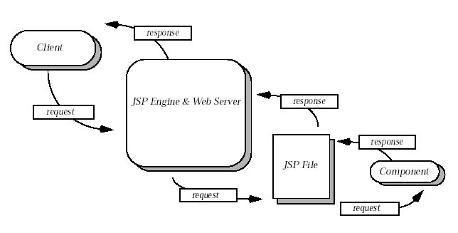

- JSP pages are interpreted only once; to java byte-code and reinterpreted only when the file is modified.

- JSP supports both scripting based and element based dynamic content, and allows programmers to develop custom tag libraries to satisfy application-specific needs.

- JSP pages are pre-compiled for efficient server processing.

- JSP run on all the main web servers.

It is true that both servlets and JSP pages have many features in common and can be used for serving up dynamic web content.naturally,this may cause some confusion as to when to opt for one of the technologies over the other. Java Server Pages provide a much cleaner separation of presentation from logic, and are simpler to write. Together, JSP technology and servlets provide an attractive alternative to other types of dynamic web scripting/programming that offers platform independence, enhanced performance, separation of logic from display, ease of administration, extensibility into the enterprise and most importantly, ease of use.

Server Components
Server components can be in form of EJBs (Enterprise Java beans). EJB’s executes within a container that manages the runtime behavior of EJBs.

Working with the Model View Controller
Typically entity beans are used to provide the model logic, while a mix of entity beans and session beans are used to provide the control logic and web components are used to Implement both control and presentation logic.

The Java Beans specification allows software components to be written in java, which encapsulates the logic behind the web application and remove the bulk of the script let code that would otherwise clutter up the jsp.The result JSP code that is simpler, easier to maintain, and which is more readily accessible to non-programmers.

Java uses the beans specification to allow the creation of software components that can be used by other developers and designers to build specialist applications. Java’s cross platform nature means that the same Java bean should be reusable across any machine. This really frees us from dependence on any particular platform

3.5 BEA WEB LOGIC

SERVER SPECIFICATION
Every application needs an application server that provides a runtime environment for them. We also needed an application server for the successful working of our application. One reason for using J2EE as a web development tool is that various application servers support it. Hence, we have a choice to select servers such as BEA Web logic, ATG dynamic and IBM Web Sphere. Among all these, our choice was BEA Web Logic. Web Logic is an industry-leading product that gives maximum choice and flexibility in building robust inspection tool applications that extend from web to the enterprise. It is high performance Java application server, which incorporates the most comprehensive implementation of the Java 2 Enterprise Edition (J2EE) standards.

Web Logic server provides the foundation for the rapid development of web applications and the performance and reliability required for mission-critical inspection tool sites. the reasons for choosing Web Logic in our application are,

- Java Server Pages (JSP’s), Java Message Services (JMS), Java Database Connectivity (JDBC) as specified by the J2EE standard.

- Support for Oracle database.

- Multitiered JDBC which allows a Java application to access and update database from anywhere on the network. The server includes it’s native JDBC driver fro leading database product and works.

Bea-Web Login Application Server Architecture
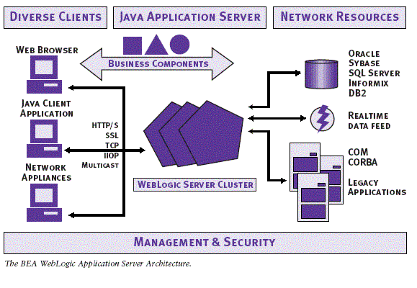
The BEA Web Logic Application Server
An integrated platform for assembling, deploying, and managing multi-tier java applications. BEA Web Logic is a Java application server for developing, integrating, deploying, and managing large-scale, distributed Web, network, and database applications. Defining the Java application server market,
BEA Web Logic:
- Fully implements 10 of the 12Enterprise Java APIs, including JDBC, EJB, RMI, event management, and JNDI
- Provides the most comprehensive implementation of the Enterprise JavaBeans 1.0 specification, including optional services such as session and entity beans
- Provides tools to aid in the creation and management of Enterprise JavaBeans, permitting the hosting of both custom and off-the-shelf business components
- Provides support for persistency to multiple databases
- Deploys and manages applications to ensure scalability, availability, and security
- Works easily with industry-leading databases, as well as Microsoft Visual Basic, Visual C++, Active Server Pages, and COM
- Works easily with industry-leading development tools, including Visual Cafe, JBuilder, Supercede, J++, and Visual Age
BEA Server Scalability
A BEA Web Logic server scales to support many clients by carefully managing threads and connections. With BEA Web Logic, a single client/server connection is shared across all bidirectional communications, regardless of the request type and the number of remote objects being accessed.
Database connections are also shared so that the maximum number of simultaneous clients can be supported. BEA Web Logic caches database query results and can automatically update cached data in real time as changes are made to the backing DBMS. Standard Internet Protocols Web browsers can access the BEA Web Logic application server via normal HTTP requests. Forwarding capabilities, such as HTTP proxying, enable dispatching to servers other than the original web server. For higher performance, HTTP connections are maintained across requests.
All BEA Web Logic services are also accessible via CORBA IIOP and TCP/sockets. Management BEA WebLogic provides centralized management for a potentially large distributed configuration of clients and servers through a ingle cohesive view of the overall system. Zero Administration Client (ZAC)
The BEA ebLogic application server supports the automatic distribution of Java applets, applications, or ystems. With ZAC, program libraries–even a new BEA Web Logic release–can be installed entrally by an administrator. BEA Web Logic pushes each updated component to all ppropriate lients. The ZAC client itself has a very small footprint. Dynamic Application Partitioning The EA Web Logic application server permits online application components to be dynamically elocated across machines. Graphical Management Console
The BEA Web Logic application erver offers a comprehensive pure-Java console for remotely monitoring and updating the state f your WebLogic application and WebLogic server cluster. Multiple clients and servers can be securely and easily managed from a single remote console. Integrated Logging The BEA ebLogic application server automatically logs diagnostic and security audit information and rovides interfaces for applications to log their own exception conditions. Optionally, HTTP raffic can be logged in common log format. Logs can be viewed remotely from a web browser r from the BEA Web Logic management console.
3.5 My Sql
Structure Query Language(SQL)
A query language for RDBMS based on. Non –procedure approach to retrieve record from RDBMS.
SQL was proposed by IBM and got its standardization by ANSI and adopted by different corporation with bit modification.
SQL can be divided into three categories as given below:
  - DML – Data Manipulation Language.
  - DCL - Data Control language.
  - DDL – Data Definition language
DML :- Primarily used to retrieve the records from RDBMS
SELECT [*|ALL] FROM <TABLE> [WHERE <CONDITION”] <ORDER BY [<FIELD>]
[HAVING<CONDITION>]
insert into <table> ( field1, field2, field3 ) values(values1, values2,values3);
DDL:- Primary used to create tables/indexes etc.
Create table <table name> (
field name1 type1,
field name2 type2,
field name3 type3
);
Drop table < table name >;
DCL:- Primarily used for administrative /option operation like creating if user/assignment of password updation of record/deletion of user/creation of roles/assignment of access right.
Create user<user name>
Identified by <password>
Grant select, insert on EMP to demo;
Revoke select on EMP from Demo;
In a summarized way it could be concluded that SQL becomes the query engine that resides over the database engine having been designed on the client-server Approach and provided retrieval of data as well as operation on RDBMS. By the Application package and web pages.

Project Category

RDBMS [Relational Database Management System]

A Relational Data Model was invented by Dr. E. F. Codd and is based on the simple concept i.e., Table.
A RDBMS is a computer program for managing table. It has three major parts:
  - Data that is presented as Tables.
  - Operators for manipulating tables.
  - Integrity rules on tables.

Introduction To MySql

Modern relational database management systems can perform a wide range of tasks. It has got the following advantages-

  - Define a database
  - Query the database
  - Add, edit and delete data.
  - Modify the structure of the database
  - Secure data from public access.
  - Communicate within networks
  - Export and import data

MySql is one such RDBMS. It provides a set of functional programs that we use a tool to build structure and performs tasks, in mysql data is stored and displayed in tables. A table is a data structure that holds data in a relational database. A table comprises of rows and columns. Table can also show relationship between entities. The formal name of table is relation, hence the name Relational Database Management System.

Access of data in mysql

SQL is a structured query language that we use to communicate with mysql. It consists of a set of English words like Select, Create etc. The standard set of SQL command fall into the following category-

  - Queries using select clause
  - Data definition language (DLL) commands which are for creating and altering the structure of database.
Salient Features of MySql

  - Open Source
  - Efficient multi-user support and consistency
  - Powerful security feature
  - Fault tolerance
  - Ease of administration
  - Application development tools
  - Networking
  - SQL compatibility
About SQL
SQL is a structured query language that we use to communicate with oracle. It consists of a set of English words like Select, Create etc. The standard set of SQL command fall into the following category-
  - Queries using select clause
  - Data definition language (DLL) commands which are for creating and altering the structure of database.
Platform used: -
Operating System: - Windows 2000 Professional OR Windows XP 2000.
Front End Tool: -
JSP, Servlet, Ajax, Java script, Ajax, CSS, HTML
Back End Tool: -
RDBMS: - MySql

Windows XP Professional
This operating system is presented by Microsoft Corp. It supports all the GUI’s facilities and is very much user friendly.
Purposes programming and other are Supporting Language for Internal Programming.
MySql
It is an Object- oriented Relational Database management System. It offers capabilities of both relational and object-oriented database management system.
CHAPTER 4:
SYSTEM DESIGN AND DEVELOPMENT

SYSTEM DESIGN AND DEVELOPMENT

4.1 SYSTEM DESIGN
Software design is a process through which requirements are translated in to a representation of software. Initially the representation depicts a holistic view of software. Subsequent refinement leads to a design representation that is very close to source code.
Since, we are following an Object oriented Design technique, the next step towards the development is to identify the classes and their relationships. A class is a description of an object type. Instances of classes are known as Objects. UML also provides tools for designing the system. Class diagrams enable us to establish relationship among various classes of the system. Before proceeding on to develop class diagrams, the next step is to identify the potential classes in the system.some of the basic tips in identifying the classes are:
- Analyzing the requirement statement.
- Use Cases.
- Application experts.
- Studying the system.

By following these simple rules during the initial process of analyzing, several classes get formulated. These classes are referred to as candidate classes and they represent the possible classes in a given system. It is not essential to incorporate all the identified candidate classes; some of them may also be dropped and are called Unfit candidate classes.

A class icon is a rectangle with three sections in it. Horizontal lines across the rectangle divide the sections. The first section is where the class name is mentioned. In the second section the attributes or data members of the class and in the third section the methods or functions of the class are mentioned. A class diagram thus takes the form

In DFD the cardinality or multiplicity can be expressed at the ends of the association at the clas where it is applicable. Whenever there is no mention of the cardinality then one is considered.

With the help of DFD, we designed the class diagram of our system, which looks like the following. The cardinality among the relationship is also mentioned.

4.2 DATAFLOW DIAGRAMS
The Data flow diagram can be explained as the separate levels indicating the individual complexity in the each level of the system and gives a detailed explanation in the further levels that are following them.
LEVEL 0
Initially in the first level of the Data flow the level 0 explains the basic outline of the system. The end-user sends the packets to the system to determine the source and destination address. The diagram marked as the 0 represents the complete Packet watching system which simply represents the basic operation that is being performed by it in the initial level.
LEVEL 1
The level 1 of the Data flow diagram given explains in detail about the Packet watching system which was marked as 0 in the previous level. In this level the end-user who passes the request for the system enters into the first process, the capturing process and then to the processing module. After processing the packets it was send for storing.
LEVEL 2
The level 2 provides the clear explanation about the whole system. In this level first we have to select the packet and perform test over that selected packets. Then identify the end address of the packet and send that packet for processing. After processing the packet it was send to the identity content. Then send the processed packet for storing and display the source and destination addresses.
DATA FLOW DIAGARAMS

O-LEVEL DFD

Admin

Student

Login

Gives Username Authentication
& Password For Admin or College

Result Analyzer

Change Password
Online Result
My Account
Course

1-Lelvel And 2 - Level DFD

Student

Login

Result Analyzer

Feedback
My Account
Course

View
give

Updation

Login
Result Analyzer
Admin

Update Course
Course

Student List

Result
Feedback
Reply Faq

CId

id
View
CName
Course
name
Update
address
myaccount
Pid
Change
Give
Feed ID
Pass
Description
View
rid
Rsub
Marks
Mobile
Student
Password
Feed Back
Result

ID
Change
Give
Faq ID
Name
Faq Details
View
rid
Rsub
Rmarks
Enroll_no
name
course
Admin
Student List
Reply Faq
Result
student
Admin

/*
SQLyog Community Edition- MySQL GUI v5.22a
Host - 5.0.19-nt : Database - result
*********************************************************************
Server version : 5.0.19-nt
*/

/*!40101 SET NAMES utf8 */;

/*!40101 SET SQL_MODE=''*/;

create database if not exists `result`;

USE `result`;

/*!40014 SET @OLD_FOREIGN_KEY_CHECKS=@@FOREIGN_KEY_CHECKS, FOREIGN_KEY_CHECKS=0 */;
/*!40101 SET @OLD_SQL_MODE=@@SQL_MODE, SQL_MODE='NO_AUTO_VALUE_ON_ZERO' */;

/*Table structure for table `answer_master` */

DROP TABLE IF EXISTS `answer_master`;

CREATE TABLE `answer_master` (
`subid` varchar(100) default NULL,
`question` varchar(100) default NULL,
`answer` varchar(100) default NULL
) ENGINE=InnoDB DEFAULT CHARSET=latin1;

/*Data for the table `answer_master` */

insert into `answer_master`(`subid`,`question`,`answer`) values ('C','kkk',NULL),('Java','ab',NULL),('Java','ab',NULL);

/*Table structure for table `auto_gen_id` */

DROP TABLE IF EXISTS `auto_gen_id`;

CREATE TABLE `auto_gen_id` (
`form_name` varchar(100) NOT NULL default '',
`prefix_id` varchar(50) default NULL
) ENGINE=InnoDB DEFAULT CHARSET=latin1;

/*Data for the table `auto_gen_id` */

insert into `auto_gen_id`(`form_name`,`prefix_id`) values ('signup','STU-00005'),('course','Course-00001'),('question','Q-00000'),('feed','Feed-00003'),('faq','Faq-00003');

/*Table structure for table `course` */

DROP TABLE IF EXISTS `course`;

CREATE TABLE `course` (
`id` varchar(100) default NULL,
`name` varchar(100) default NULL,
`fee` varchar(100) default NULL,
`duration` varchar(100) default NULL,
`seat` varchar(100) default NULL,
`collagetype` varchar(100) default NULL
) ENGINE=InnoDB DEFAULT CHARSET=latin1;

/*Data for the table `course` */

insert into `course`(`id`,`name`,`fee`,`duration`,`seat`,`collagetype`) values ('011','BBA','40000','3-year','400','Regular'),('0111','BCA','80000','3-year','5002','Regular'),('c-003','MCA','75000','4-year','50','Corresponding'),('s-003','BTech','45000','3 year','500','Regular'),('c789','MCA','8500','6-month','121','Corresponding');

/*Table structure for table `exam` */

DROP TABLE IF EXISTS `exam`;

CREATE TABLE `exam` (
`course` varchar(100) default NULL,
`sem` varchar(100) default NULL,
`branch` varchar(100) default NULL,
`center` varchar(100) default NULL,
`p1` varchar(100) default NULL,
`d1` varchar(100) default NULL,
`p2` varchar(100) default NULL,
`d2` varchar(100) default NULL,
`p3` varchar(100) default NULL,
`d3` varchar(100) default NULL,
`p4` varchar(100) default NULL,
`d4` varchar(100) default NULL,
`p5` varchar(100) default NULL,
`d5` varchar(100) default NULL
) ENGINE=InnoDB DEFAULT CHARSET=latin1;

/*Data for the table `exam` */

insert into `exam`(`course`,`sem`,`branch`,`center`,`p1`,`d1`,`p2`,`d2`,`p3`,`d3`,`p4`,`d4`,`p5`,`d5`) values ('btech','2','null','null','Computer Architecture','17-03-2011','Business Architecture','18-03-2011','CO','31-03-2011','Discripte Mathamatics','21-06-2011','MIS','01-04-2011'),('mca','1','cs','null','Computer Architecture','17-03-2011','C++','08-03-2011','Java','01-03-2011','TOC','16-03-2011','Computer Networking','28-03-2011'),('mtech','4','mac',NULL,'Computer Architecture','01-03-2011','Java','15-03-2011','Machine Architecture','16-03-2011','C++','24-03-2011','vb.net','01-04-2011'),('mba','2','Babbage','Nirothi More','Computer Architecture','08-03-2011','Java','03-03-2011','Descripte Matematics','21-03-2011','C++','31-03-2011','MIS','18-03-2011'),('btech','2','null','null','Computer Architecture','17-03-2011','Business Architecture','18-03-2011','CO','31-03-2011','Discripte Mathamatics','21-06-2011','MIS','01-04-2011'),('bba','7','Macanical','na','mc-0012','28-03-2011','mc-0013','12-04-2011','mc-0012','12-04-2011','mc-0012','12-04-2011','mc-0012','27-04-2011'),('mca','4','Computer','bgv','vbv','14-07-2011','','','','','','','',''),('btech','5','Computer','cfdf','ghgh','19-07-2011','hgh','','','','','','',''),('bca','1','Electical','GDGF','BNVBN','03-11-2011','JGJH','03-11-2011','GBJH','03-11-2011','VGBNGV','03-11-2011','VBNV','03-11-2011');

/*Table structure for table `exam_schedule` */

DROP TABLE IF EXISTS `exam_schedule`;

CREATE TABLE `exam_schedule` (
`subject` varchar(100) default NULL,
`date` varchar(100) default NULL,
`time` varchar(100) default NULL
) ENGINE=InnoDB DEFAULT CHARSET=latin1;

/*Data for the table `exam_schedule` */

insert into `exam_schedule`(`subject`,`date`,`time`) values ('Java','20-07-2011','8:00 AM to10:00 AM'),('Java','14-07-2011','2:00 PM to4:00 PM');

/*Table structure for table `faq` */

DROP TABLE IF EXISTS `faq`;

CREATE TABLE `faq` (
`id` varchar(100) default NULL,
`name` varchar(100) default NULL,
`tip` varchar(100) default NULL,
`date` varchar(100) default NULL
) ENGINE=InnoDB DEFAULT CHARSET=latin1;

/*Data for the table `faq` */

insert into `faq`(`id`,`name`,`tip`,`date`) values ('Faq-00001','a','mhat is java','2012-02-09 21:49:46'),('Faq-00002','rajiv','what is my case status.','2012-06-23 12:59:11'),('Faq-00003','raj','fsdaf','2012-07-02 12:48:03');

/*Table structure for table `feedback` */

DROP TABLE IF EXISTS `feedback`;

CREATE TABLE `feedback` (
`id` varchar(100) default NULL,
`name` varchar(100) default NULL,
`gift` varchar(100) default NULL,
`discription` varchar(1000) default NULL
) ENGINE=InnoDB DEFAULT CHARSET=latin1;

/*Data for the table `feedback` */

insert into `feedback`(`id`,`name`,`gift`,`discription`) values ('Feed-00001','ranjeet','hgfg','UserImage_1320388731444.doc'),('Feed-00002','ka','gjsadfgjsadfgjsadf','UserImage_1320389587553.doc'),('Feed-00003','raj','dfgsdfgsdfg','UserImage_1341210204031.jpg');

/*Table structure for table `login` */

DROP TABLE IF EXISTS `login`;

CREATE TABLE `login` (
`uname` varchar(50) default NULL,
`pass` varchar(50) default NULL
) ENGINE=InnoDB DEFAULT CHARSET=latin1;

/*Data for the table `login` */

insert into `login`(`uname`,`pass`) values ('a','a');

/*Table structure for table `payment` */

DROP TABLE IF EXISTS `payment`;

CREATE TABLE `payment` (
`mode` varchar(100) default NULL,
`bank` varchar(100) default NULL,
`pin` varchar(100) default NULL,
`amount` varchar(100) default NULL
) ENGINE=InnoDB DEFAULT CHARSET=latin1;

/*Data for the table `payment` */

insert into `payment`(`mode`,`bank`,`pin`,`amount`) values ('Credit-Card','Central_Bank','565','fg545'),('ATM','Central_Bank','7895','450001'),('ATM','Central_Bank','454','45444445');

/*Table structure for table `question_master` */

DROP TABLE IF EXISTS `question_master`;

CREATE TABLE `question_master` (
`ques_id` varchar(50) NOT NULL default '',
`sub_id` varchar(50) NOT NULL default '',
`question` varchar(200) NOT NULL default '',
`answer` varchar(100) NOT NULL default '',
`option1` varchar(100) NOT NULL default '',
`option2` varchar(100) NOT NULL default '',
`option3` varchar(100) NOT NULL default '',
`option4` varchar(100) NOT NULL default '',
`status` int(10) default '0'
) ENGINE=InnoDB DEFAULT CHARSET=latin1;

/*Data for the table `question_master` */

insert into `question_master`(`ques_id`,`sub_id`,`question`,`answer`,`option1`,`option2`,`option3`,`option4`,`status`) values ('Q-00006','Java','ab','a','f','a','d','d',1),('Q-00007','Java','abc','a','ff','a','d','d',1),('Q-00008','Java','What is Operators?','ABC','AAA','BBB','CCC','ABC',1),('Q-00009','Java','What is Bollean Operators?','BBB','ABC','TTT','BBB','CCC',1),('Q-00010','Java','ggggg','ff','gg','ff','fv','hjj',1),('Q-00011','Java','bhgh','g','g','ff','ftf','ghgf',1),('Q-00012','Java','fff','dj','k','dj','ki','ijj',1);

/*Table structure for table `reply` */

DROP TABLE IF EXISTS `reply`;

CREATE TABLE `reply` (
`id` varchar(100) default NULL,
`comment` varchar(100) default NULL,
`by1` varchar(100) default NULL,
`date` varchar(100) default NULL
) ENGINE=InnoDB DEFAULT CHARSET=latin1;

/*Data for the table `reply` */

insert into `reply`(`id`,`comment`,`by1`,`date`) values ('Faq-00001','java is language','kk','2012-02-09 21:54:14'),('Faq-00001','bbbbbbbbb','raju','2012-04-14 17:06:43'),('Faq-00001','666666','ankit123','2012-06-23 12:50:25'),('Faq-00002','i am woriking noew','ankit123','2012-06-23 13:01:14');

/*Table structure for table `result` */

DROP TABLE IF EXISTS `result`;

CREATE TABLE `result` (
`id` varchar(100) default NULL,
`name` varchar(100) default NULL,
`course` varchar(100) default NULL,
`sem` varchar(100) default NULL,
`pep1` varchar(100) default NULL,
`pep2` varchar(100) default NULL,
`pep3` varchar(100) default NULL,
`pep4` varchar(100) default NULL,
`pep5` varchar(100) default NULL,
`pep6` varchar(100) default NULL,
`total` varchar(100) default NULL,
`grade` varchar(100) default NULL
) ENGINE=InnoDB DEFAULT CHARSET=latin1;

/*Data for the table `result` */

insert into `result`(`id`,`name`,`course`,`sem`,`pep1`,`pep2`,`pep3`,`pep4`,`pep5`,`pep6`,`total`,`grade`) values ('011','kamalkant kumar','btech','6','78','45','96','85','22','22','348','second'),('022','ruby kumari','bca','5','89','56','23','78','21','12','303','second'),('033','Lily Kumari ','mca','7','22','23','12','14','12','78','161','second'),('12','rgfd','bca','1','70','50','80','65','87','78','430','first');

/*Table structure for table `signup` */

DROP TABLE IF EXISTS `signup`;

CREATE TABLE `signup` (
`UserID` varchar(50) NOT NULL default '',
`uname` varchar(50) NOT NULL,
`pass` varchar(50) default NULL,
`FirstName` varchar(100) default NULL,
`LastName` varchar(100) default NULL,
`Gender` varchar(25) default NULL,
`DOB` varchar(25) default NULL,
`ContactNo` varchar(15) default NULL,
`EmailID` varchar(100) default NULL,
`Address` varchar(200) default NULL,
`City` varchar(100) default NULL,
`PinCode` varchar(10) default NULL,
`State` varchar(100) default NULL,
`Country` varchar(100) default NULL,
`image` varchar(500) default NULL,
`status` varchar(100) default 'false'
) ENGINE=InnoDB DEFAULT CHARSET=latin1;

/*Data for the table `signup` */

insert into `signup`(`UserID`,`uname`,`pass`,`FirstName`,`LastName`,`Gender`,`DOB`,`ContactNo`,`EmailID`,`Address`,`City`,`PinCode`,`State`,`Country`,`image`,`status`) values ('STU-00001','raj','raj','','','Select','','','','','Select','','','Select','UserImage_1310891370531.jpg','false'),('STU-00002','gfg','fgf','','','Select','','','','','Select','','','Select','UserImage_1310891392765.jpg','false'),('STU-00003','ka','ka','','','Select','','','','','Select','','','Select','UserImage_1311052251171.mp3','false'),('STU-00004','ranjeet','kumar','ranjeet','kumar','Male','19-07-2011','5454567676','hjhjk@gmail.com','kjfkdj','Delhi','5454','fg','America','UserImage_1311184236093.jpg','false'),('STU-00005','umesh','1234','umesh','asdf','Male','28-06-2012','9876543212','pramod@gmail.com','','Select','','','Select','UserImage_1340884878515.jpg','false');

/*!40101 SET SQL_MODE=@OLD_SQL_MODE */;
/*!40014 SET FOREIGN_KEY_CHECKS=@OLD_FOREIGN_KEY_CHECKS */;

Screen Shot

Login page
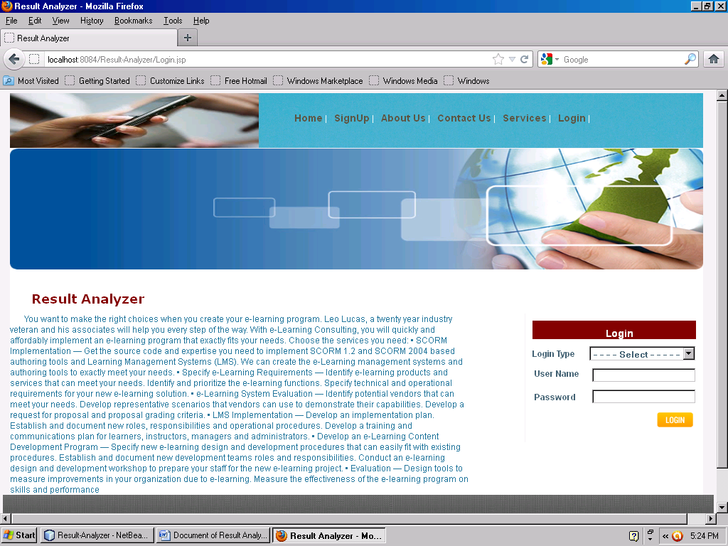
Home Page
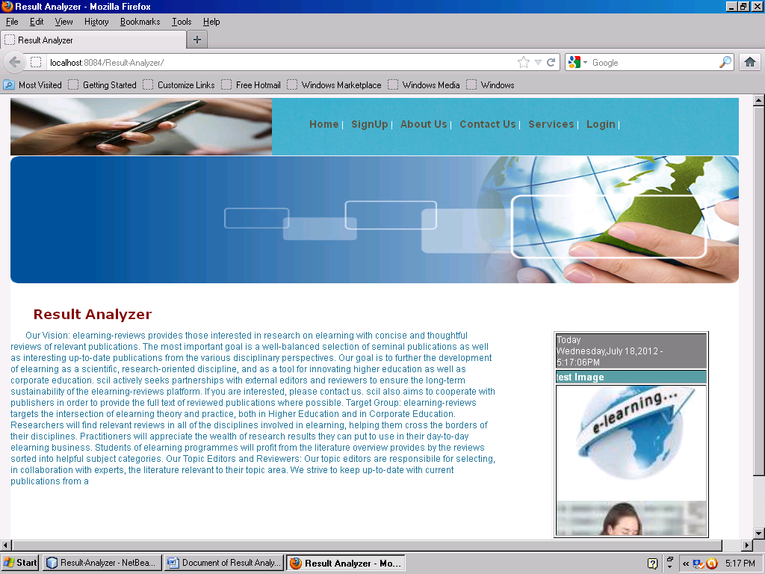
Sign Up
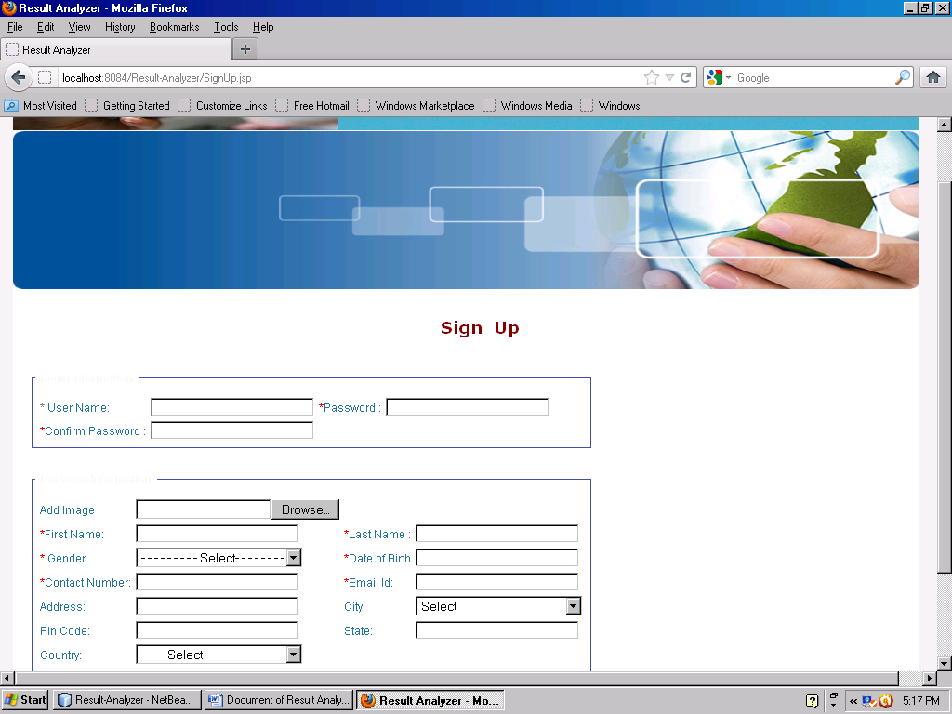
About Us
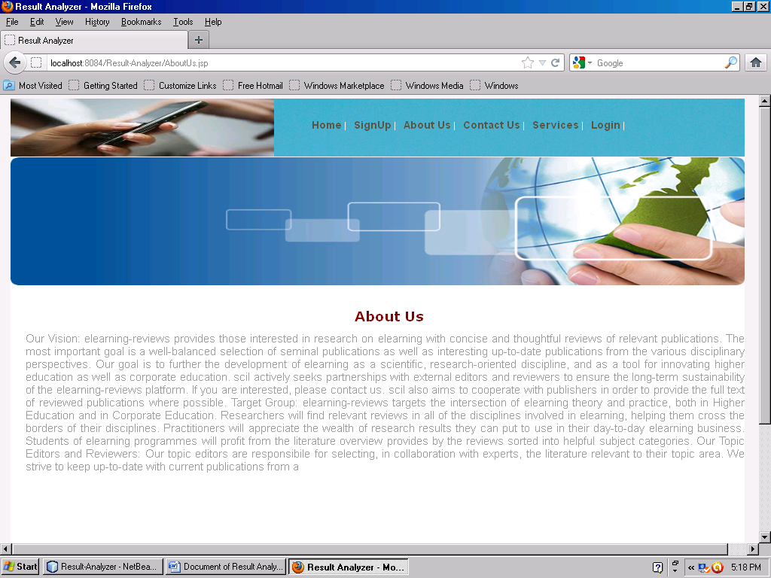
Contact Us
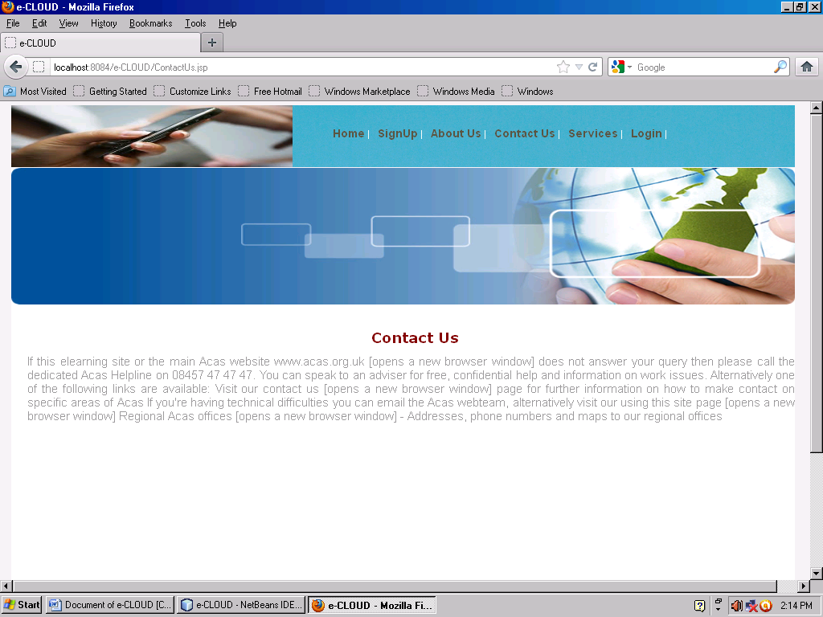
Services
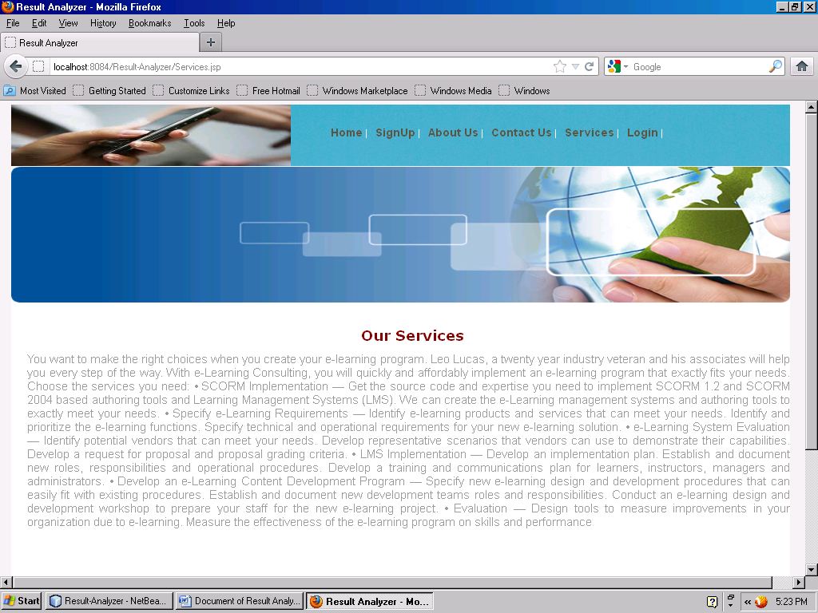
Admin
Student List
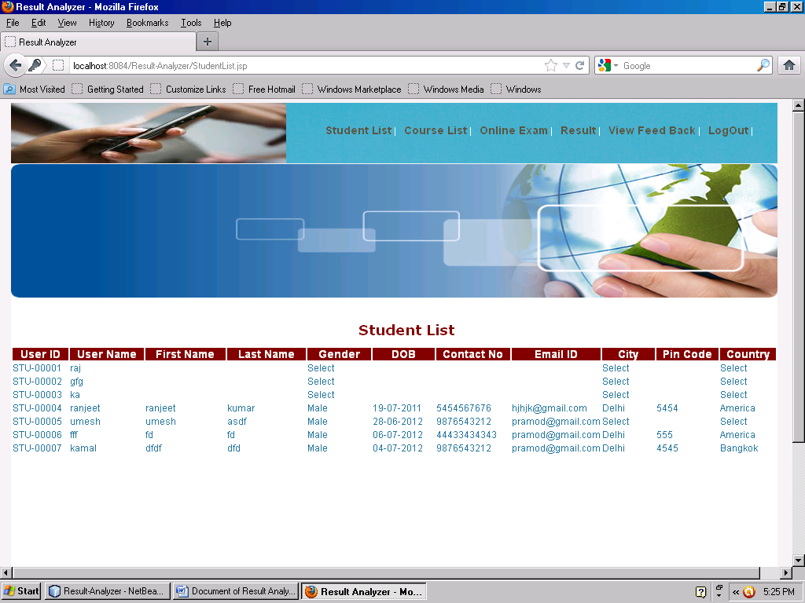
Course List
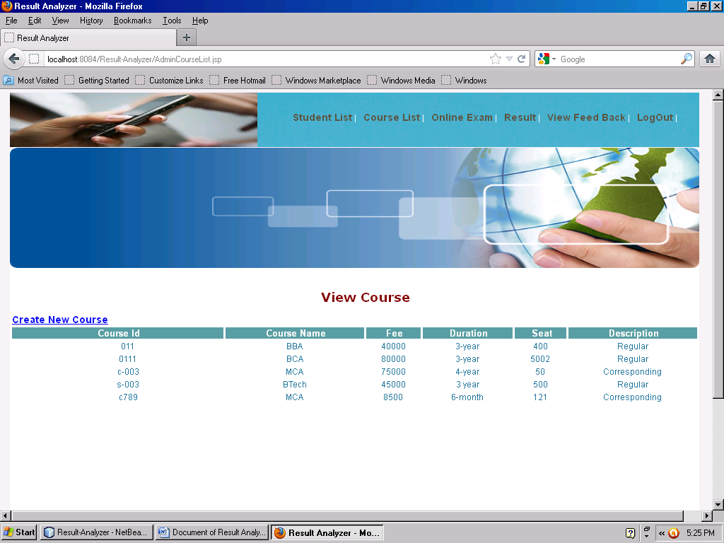
Create New Course
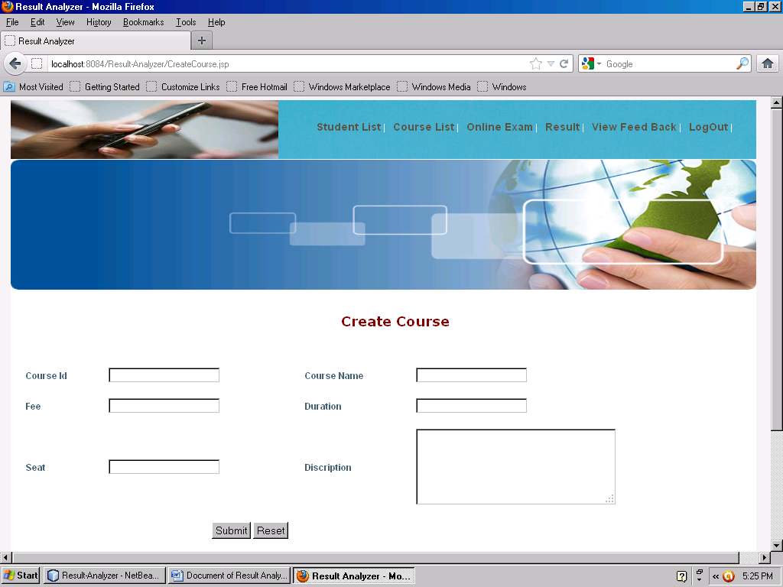
Result
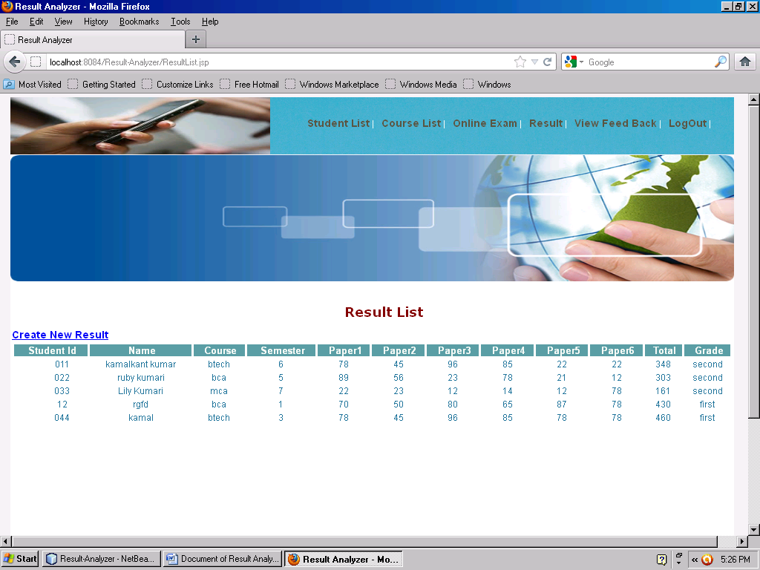
Create New Result
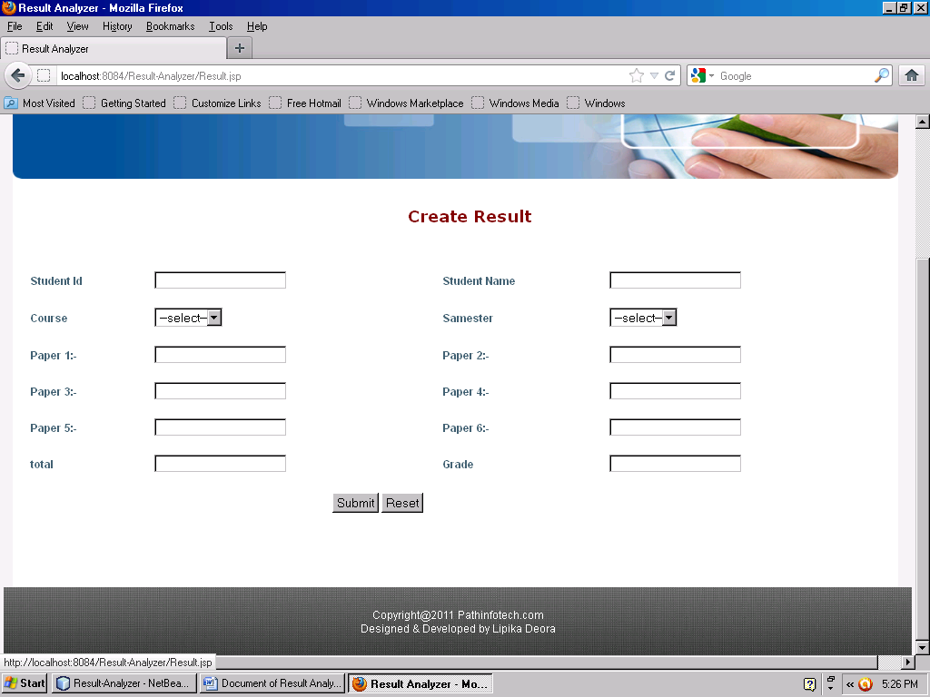
View Feed Back
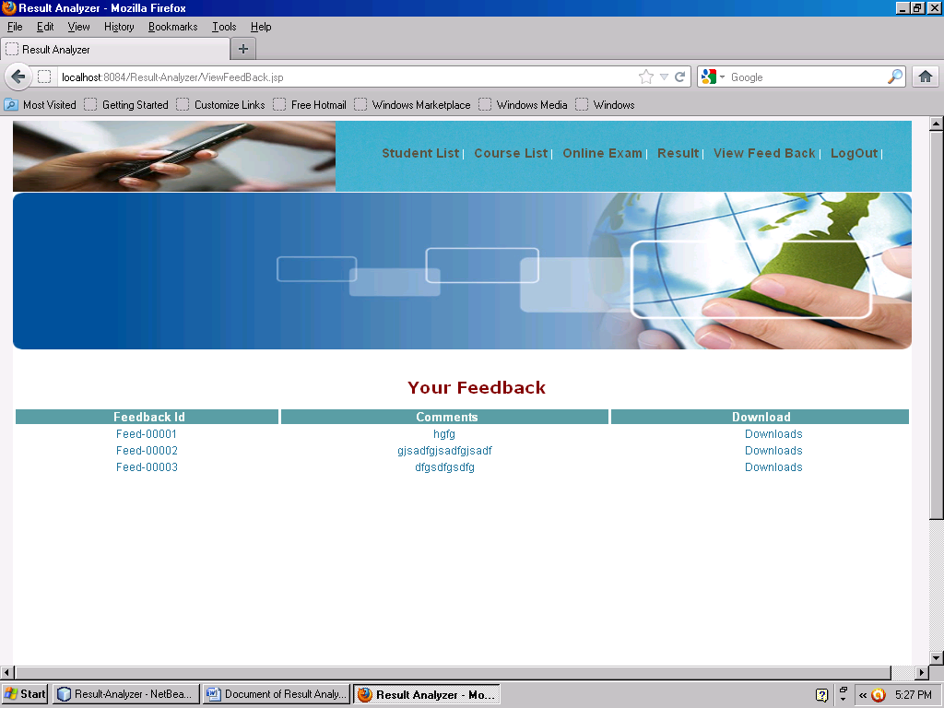

Student
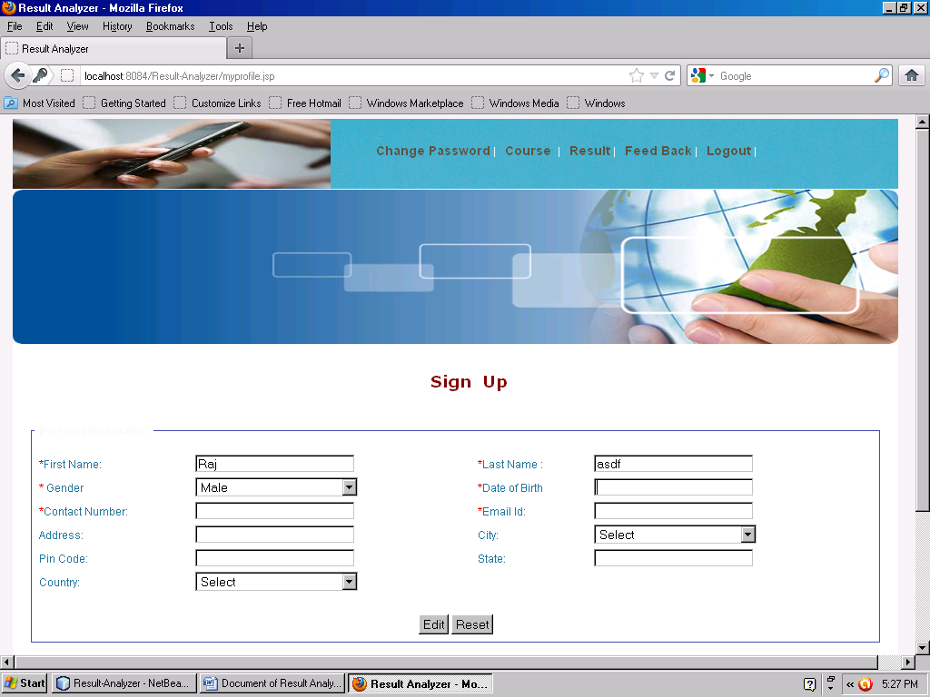
Change Password
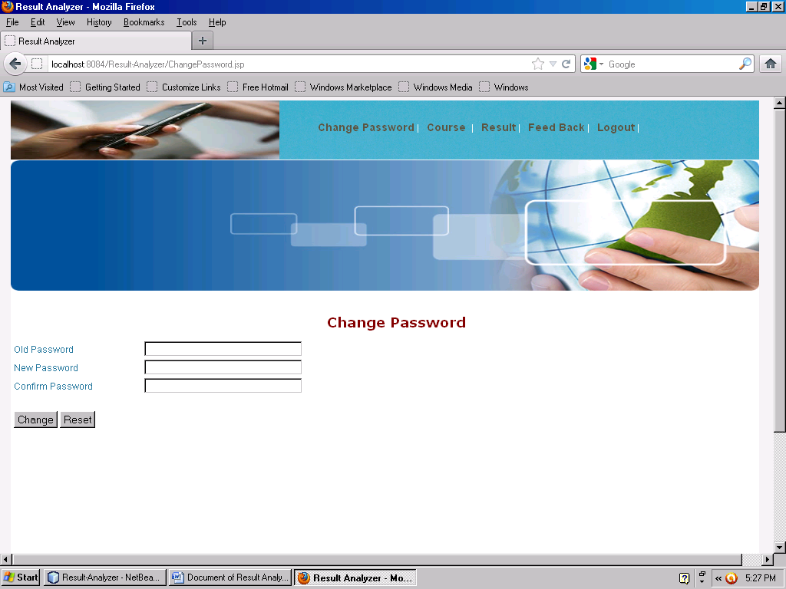
Course
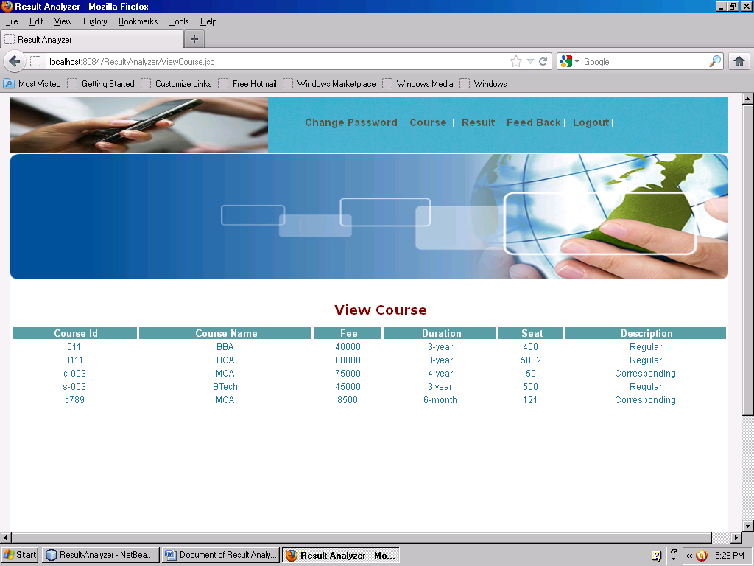
Result
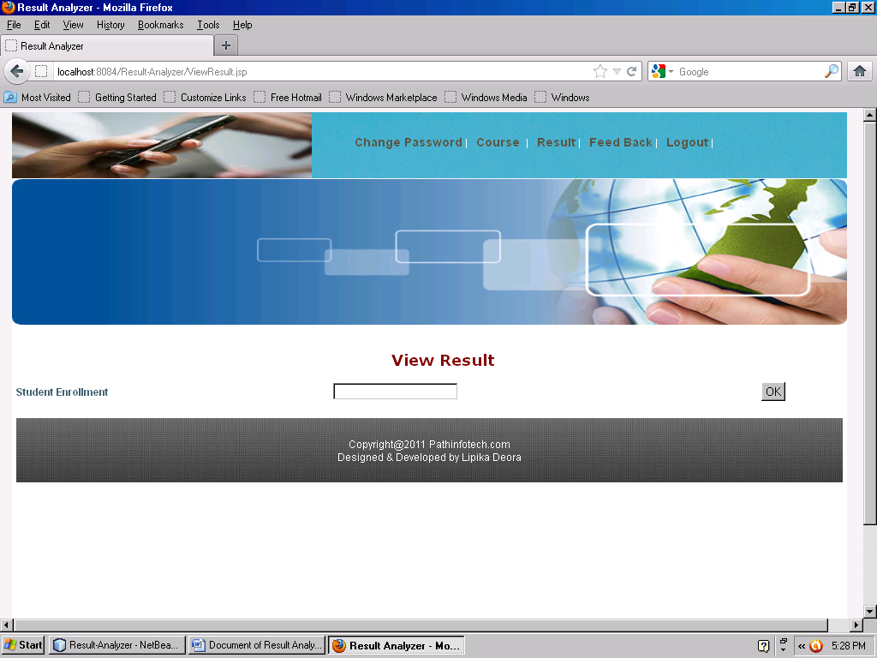
Feed Back
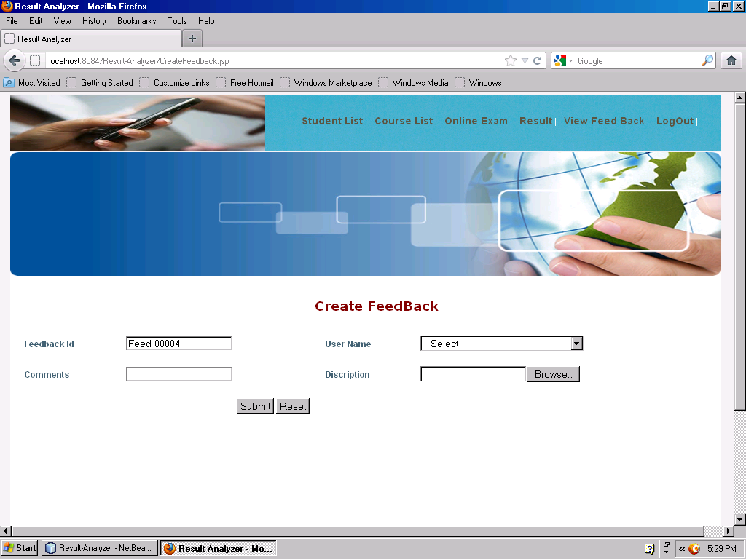

CHAPTER 5:
SYSTEM TESTING
AND
IMPLEMENTATION

SYSTEM TESTING AND IMPLEMENTATION

The testing and implementation they are important and final phases. All the process that has been done is just a trail or by assumption. All the required hardware & software is prepared for the testing so that some errors or some modifications may be required for further proceeding.

  - SYSTEM TESTING

Testing is vital to the success of the system. System testing makes a logical assumption that if all parts of the system are correct. The goal will be successfully achieved. There are four steps with in, they are,

- Unit Testing
- Integration Testing
- Validation testing
- Output Testing

    - UNIT TESTING
In this testing, the smaller part of the project is tested first that is modules and the sub functions present in the project. It seems to be working satisfactorily with out the errors and that shows the unit testing is successful.

    - INTEGRATION TESTING
The integration testing is a part that the software makes all functions behaviors and process required. The errors which are uncovered are integrated testing, are corrected during this phase. The collection of the functions are tested and found with errors are rectified .So that the result can be easily obtained in a successful manner.

5.1.3 VALIDATION TESTING

The validation part is very much essential for each every application projects so that each data can be validated in a good manner. In some cases the records are created according to the key of the corresponding table to which it has been referenced for data constraint for good secured database. While testing the system by using test data errors are again uncovered and corrected by using above testing steps and corrections are also noted for future use. If there is any error then it is allowed for testing from the beginning.

    - OUTPUT TESTING

The output is major required part of the development of the project. The output is tested for required format, if it does not acquire such format then the testing is done or any screen modification is alone for the further operations. The output testing is mainly for the two things they are,
- On screen format
- Print format
The screen is found to be correct as the format designed according to the user needs for the hard copy also; the output comes out as specified by the user. Hence output testing doesn’t result in any correction in the system.

5.2 SYSTEM IMPLEMENTATION

Training the operating staff
Installing hardware
Installing terminals
Installing telecommunication network before system is up and running.
In the implementation phase, the project reached its fruition. After the development phase of the SDLC is complete, the system is implemented. The software, which was designed in design and programmed in development phase of the SDLC, was installed on all the PCs that require it. The persona’s using the program was trained during this phase of the SDLC. Moreover, both the hardware and software are tested. Although we found and fixed many problems, almost invariably, the user’s helped us to uncover problems that we were unable to simulate.
These were the main activities performed by us in the course of the project, which lead to its proper completion.

  - POST IMPLEMENTATON REVEIW
When computer based systems are built therefore we must develop mechanism for evaluating controlling and making modifications, maintenance issued to improve the case with which the changes can be accommodated and reduce the amount of expended on its maintenance activity occurs because it is unreasonable to assume that software testing will uncover all latest errors in a large software system. The final event in the post implementation flow is review that revalidates all elements of the system configuration and ensures correctness, after the software maintenance, software reviews is being conducted for future maintenance effort and provides feedback, which is important to effectively management of software organization.

SCOPE & CONCLUSION

SCOPE & CONCLUSION

7.1 Future Scope:

- For students desiring on-the-job experience prior to graduation, an internship course may be available.
- Graduates of the program will be prepared to assume positions as office managers, administrative services coordinators or assistants, office supervisors, records and information supervisors, personnel administrators, administrative assistants, or administrative support secretaries.
- Students may transfer to a four-year institution to pursue a bachelor’s degree in business administration, business education, human resources, advertising, or public relations
- Organization automation system is very helpful in collecting the record of an organization efficiently and in less time.
- It requires less man power to keep the record and to update it time to time quickly.
- Less skilled labour is needed to maintain the database in comparison to the traditional office management.
- Insertion and deletion of a particular field or any name in the any position except the last one is very typical in traditional office management but very easy in this case.
- Useful for collecting the record worldwide through the net and hence useful for multinational companies
7.2 LIMITATION
- Due to unavailability of templates it is impossible to generate different types of framework ,here we need to develop them by our own.

- Since Microsoft and Java the testing becomes cumbersome.

7.3 CONCLUSION
There was a lot of fun in making this project. This project was very useful to us as it provided us the inside view of the planning and implementation of the data base. In this project we had to think about the various options which we can provide to user. The implementation was not easy as we had to look into the minute details in order to achieve my goals. We have tried to make this project user friendly and also interactive by providing many features.
We are satisfied by achieving the goals for which we had planned. A lot of experimental work can be done with this project. Looking forward for any advice which can help us to improve the project.

CHAPTER 8:
REFERENCES

REFERENCES

Various sites referred to during making of the project are as follows:
- www.en.wikipedia.org
- www.google.com
- www.howstuffworks.com
- www.roseindia.net
- www.w3cschools.com

Various books referred to for Java, HTML, XML & DHTML clarification and documentation are as follows:

- Advanced Java 2 Platform by Harvey. M. Dietal.
- Core Java 2, Volume II-Advanced Features by Cay Horetmann Gary Cornelll.
- Head First Servlets and Jsp by by Oreilly.
- Head First HTML with CSS by Chris Schalk(Author), Ed Burns (Author), James Holmes.
- HML and XHTML by Chuck Musciano and Bill Kennedy.
- Java Handbook by Patrick Naughton.
- Professional Java Programming by Brett Spell.
- Programming with Java by E. Balaguruswamy.
- The Best-Practice Guide to XHTML by Patrick Griffiths.

